Tutorial 6

Task 3 specified that transfer learning should be used on an existing dataset. In this tutorial, the Oxford-IIIT Pet Dataset was used. A random image was taken from the dataset and all 5 models’ top 5 predictions were printed. In this tutorial, the following models were used:
- VGG16
- ResNet50
- ResNet101
- AlexNet
- MobileNetv2
The models are imported using Pytorch’s library (torchvision). The weights from the ImageNet dataset are loaded by specifying weights as ‘IMAGENET1K_V1’. Also the labels from ImageNet are also loaded. A transform pipeline is used to make the images ready for use with the models. This involves resizing to 224x224 pixels and converting images to a tensor.
Here are some of the results:
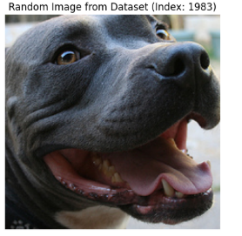
--- Top 5 Predictions (RESNET101) ---
1. American Staffordshire terrier (57.09%)
2. Staffordshire bullterrier (16.52%)
3. bull mastiff (13.28%)
4. Great Dane (2.70%)
5. Weimaraner (2.51%)

--- Top 5 Predictions (ALEXNET) ---
1. tub (36.80%)
2. bathtub (28.20%)
3. plastic bag (3.63%)
4. tick (3.45%)
5. bubble (3.02%)

--- Top 5 Predictions (MOBILENET) ---
1. dugong (35.42%)
2. Weimaraner (12.01%)
3. jellyfish (6.31%)
4. sunscreen (4.63%)
5. electric ray (4.33%)

--- Top 5 Predictions (RESNET50) ---
1. American Staffordshire terrier (50.99%)
2. Weimaraner (26.57%)
3. Chesapeake Bay retriever (11.79%)
4. Staffordshire bullterrier (4.38%)
5. Labrador retriever (1.50%)

--- Top 5 Predictions (VGG16) ---
1. Weimaraner (25.31%)
2. bonnet (9.95%)
3. stingray (8.15%)
4. electric ray (4.64%)
5. shower cap (4.47%)

Actual Label: American Pit Bull Terrier

--- Top 5 Predictions (RESNET101) ---
1. keeshond (92.68%)
2. Pomeranian (4.79%)
3. Samoyed (2.18%)
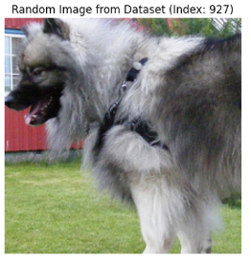
4. Great Pyrenees (0.06%)
5. Arctic fox (0.05%)

--- Top 5 Predictions (ALEXNET) ---
1. Samoyed (29.06%)
2. Pekinese (12.80%)
3. Persian cat (9.61%)
4. Angora (6.16%)
5. Great Pyrenees (5.41%)

--- Top 5 Predictions (MOBILENET) ---
1. Samoyed (67.21%)
2. Great Pyrenees (16.84%)
3. white wolf (6.38%)
4. keeshond (2.46%)
5. collie (1.29%)

--- Top 5 Predictions (RESNET50) ---
1. keeshond (74.82%)
2. Samoyed (17.76%)
3. Pomeranian (6.86%)
4. white wolf (0.10%)
5. groenendael (0.07%)

--- Top 5 Predictions (VGG16) ---
1. Samoyed (47.31%)
2. keeshond (42.31%)
3. Pomeranian (2.86%)
4. Great Pyrenees (2.67%)
5. collie (0.96%)

Actual Label: Keeshond
--- Top 5 Predictions (RESNET101) ---
1. American Staffordshire terrier (69.85%)
2. Staffordshire bullterrier (28.94%)
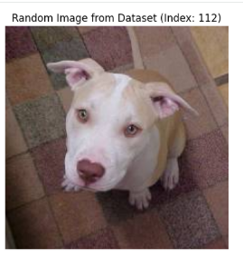
3. toilet seat (0.46%)
4. whippet (0.08%)
5. tub (0.07%)

--- Top 5 Predictions (ALEXNET) ---
1. toilet tissue (15.04%)
2. tub (12.95%)
3. bathtub (5.70%)
4. paper towel (5.59%)
5. piggy bank (4.59%)

--- Top 5 Predictions (MOBILENET) ---
1. American Staffordshire terrier (66.61%)
2. Staffordshire bullterrier (16.52%)
3. toilet tissue (3.26%)
4. shower curtain (1.77%)
5. bathtub (0.99%)

--- Top 5 Predictions (RESNET50) ---
1. American Staffordshire terrier (67.12%)
2. Staffordshire bullterrier (31.98%)
3. West Highland white terrier (0.17%)
4. whippet (0.12%)
5. boxer (0.09%)

--- Top 5 Predictions (VGG16) ---
1. toilet tissue (21.22%)
2. Staffordshire bullterrier (15.27%)
3. paper towel (15.10%)
4. American Staffordshire terrier (10.83%)
5. Eskimo dog (2.63%)

Actual Label: American Pit Bull Terrier

Since the OxfordPets Dataset has a larger variety of dogs in its dataset than the dataset the model’s were trained on (ImageNet), it is expected that there would be inaccurate classifications. Overall, both the ResNet models perform better than the rest as they can successfully identified a breed closest to the actual breed of the dog. AlexNet struggles a lot as in certain cases its top predictions involve toilet tissue or tub. MobileNet was able to predict keeshond in its top 5 results, though that it did not assign the highest probability to that breed. It even misclassified a dog as a dugong in one case.

